Creating Batch files for SiteTools

Clicking the “Export Site Tools Batch File” button will bring up a description of the file format that VTrees will generate. This is the file that SiteTools will read and base the returned site index values on.
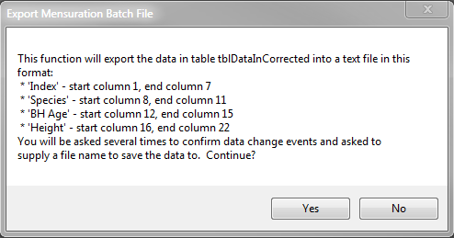
Clicking yes will get the process underway by first generating a table named “tblStandAge”. This table will contain the maximum age found in each plot. Plots without a recorded age will be ignored because age is a required data item for SiteTools.
VTrees will next ask for a filename and a location to store the file in. The file extension .dat will be automatically added. Clicking “Save” button should result in the file being generated and saved and a brief dialog stating that the task has been completed.
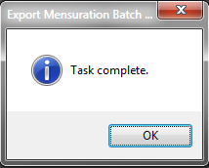

Working with Batch files in SiteTools 3.3

Opening SiteTools (btools.exe) and clicking New in the file menu will get you started. In this first form you will enter the name of the input file you created in the previous step. It is important at this stage not to enter the location of the site index.
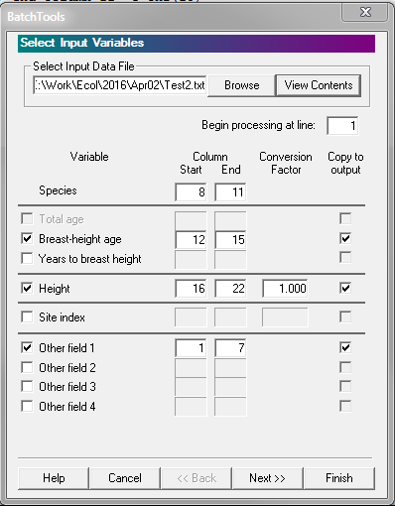

After clicking the Next button, you will get the output form. This is the form where you’ll enter the site index location. Don’t forget to enter the location and name of the output file.
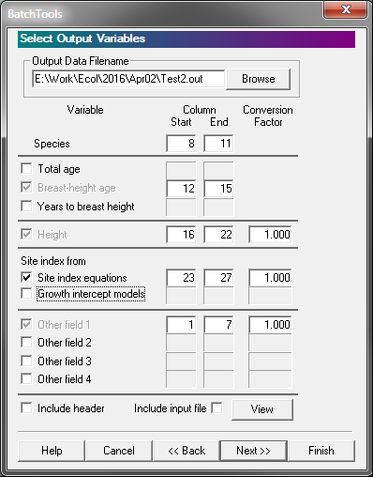
Clicking the Finish button will complete your work in SiteTools.

